ECA0901 – DIGITAL SIGNAL PROCESSING

C01 – AT3 SIMULATION EXPERIMENT – 2

➔ Expected Outcome from this Experiment:
Students shall be able to:
1. Design Chebyshev Type-I low-pass and high-pass filters and obtain the corresponding filter coefficients.
2. Determine the required filter order and verify the specified passband ripple.
3. Generate and interpret magnitude and phase responses and determine the usable bandwidth.
4. Compare Chebyshev and Butterworth responses in terms of ripple, transition behavior and order.
4. Compare Chebyshev Type-I and Butterworth responses in terms of ripple, transition behavior and filter order.
MATLAB with Signal Processing Toolbox.

MATLAB CODE:
clc; clear; close all;
Fs = 1000; Fp = 100; Fst = 150;
Rp = 1; Rs = 40;
% Chebyshev Type-I Low-Pass Filter
[Nlp,Wlp] = cheb1ord(Fp/(Fs/2),Fst/(Fs/2),Rp,Rs);
[blp,alp] = cheby1(Nlp,Rp,Wlp,'low');
% Chebyshev Type-I High-Pass Filter
[Nhp,Whp] = cheb1ord(1-Fst/(Fs/2),1-Fp/(Fs/2),Rp,Rs);
[bhp,ahp] = cheby1(Nhp,Rp,Whp,'high');
% Butterworth Low-Pass Filter
[Nb,Wb] = buttord(Fp/(Fs/2),Fst/(Fs/2),Rp,Rs);
[bb,ab] = butter(Nb,Wb,'low');
% Display orders and coefficients
fprintf('Chebyshev LPF Order = %d\n',Nlp);
disp('LPF Numerator:'); disp(blp);
disp('LPF Denominator:'); disp(alp);
fprintf('Chebyshev HPF Order = %d\n',Nhp);
disp('HPF Numerator:'); disp(bhp);
disp('HPF Denominator:'); disp(ahp);

fprintf('Butterworth LPF Order = %d\n',Nb);

% Frequency response
[Hlp,f] = freqz(blp,alp,2048,Fs);
[Hhp,~] = freqz(bhp,ahp,2048,Fs);
[Hb,~] = freqz(bb,ab,2048,Fs);

% Verify passband ripple
dbLP = 20*log10(abs(Hlp)+eps);
dbHP = 20*log10(abs(Hhp)+eps);

fprintf('LPF Passband Ripple = %.3f dB\n', ...
max(dbLP(f<=Fp))-min(dbLP(f<=Fp)));

fprintf('HPF Passband Ripple = %.3f dB\n', ...
max(dbHP(f>=150))-min(dbHP(f>=150)));

% LPF magnitude and phase
figure;
subplot(2,1,1);
plot(f,dbLP,'b',f,20*log10(abs(Hb)+eps),'r--');
grid on; ylim([-100 5]);
title('LPF Magnitude Response');
xlabel('Frequency (Hz)'); ylabel('Magnitude (dB)');
legend('Chebyshev-I','Butterworth');

subplot(2,1,2);
plot(f,unwrap(angle(Hlp)));
grid on; title('LPF Phase Response');
xlabel('Frequency (Hz)'); ylabel('Phase (rad)');

% HPF magnitude and phase
figure;
subplot(2,1,1);
plot(f,dbHP);
grid on; ylim([-100 5]);
title('Chebyshev-I HPF Magnitude Response');
xlabel('Frequency (Hz)'); ylabel('Magnitude (dB)');

subplot(2,1,2);
plot(f,unwrap(angle(Hhp)));
grid on; title('HPF Phase Response');
xlabel('Frequency (Hz)'); ylabel('Phase (rad)');
% Compare filter orders
figure;
bar([Nlp Nhp Nb]);
set(gca,'XTickLabel',{'Chebyshev LPF',...
'Chebyshev HPF','Butterworth LPF'});
ylabel('Filter Order');
title('Filter Order Comparison');
grid on;
% Usable bandwidth at -1 dB
idxLP = find(dbLP >= -Rp);
idxHP = find(dbHP >= -Rp);

fprintf('LPF usable passband: 0 to %.2f Hz\n',f(idxLP(end)));
fprintf('HPF usable passband: %.2f to %.2f Hz\n',...
f(idxHP(1)),Fs/2);

OUTPUT:
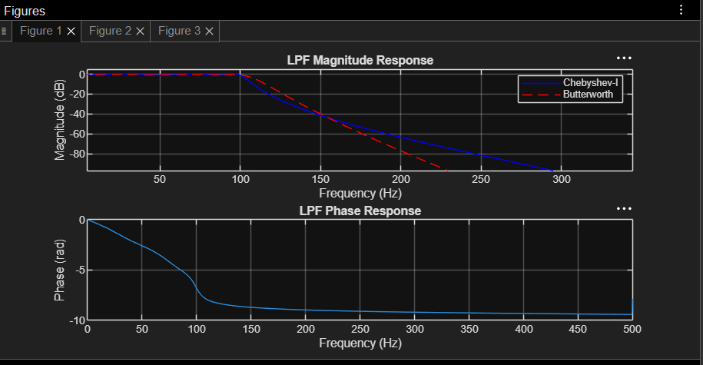

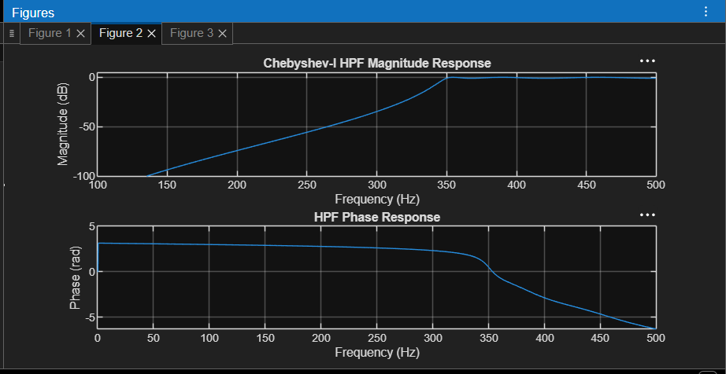

OUTPUT PARAMETERS:
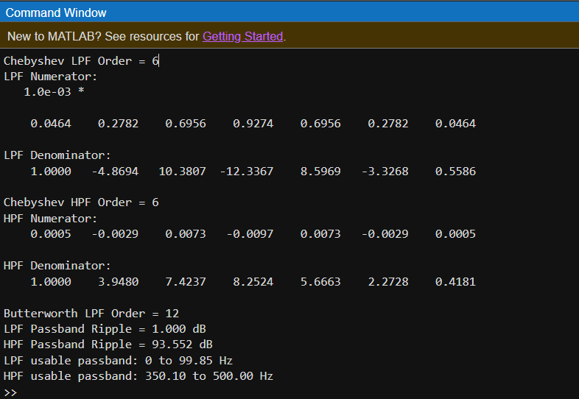

RESULT :
The Design and Performance Analysis of Chebyshev Type-I IIR Low-Pass and High-Pass Filters Using MATLAB is satisfies the expected outcomes

